

CASES Division Committee information
June 2025

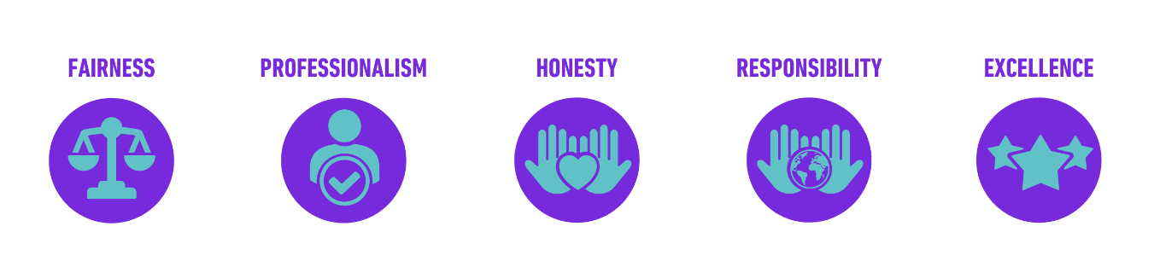

Division Committee Information
CASES Division Chairs oversee a committee consisting of:
- Chair
- Deputy Chair
- CPD Representative
- Membership Representative
- Student Representatives (Postgraduate and Undergraduate)
The Division Chair’s primary role is to ensure their Division is appropriately represented at Board meetings, as CASES seeks to reflect all five disciplines within its strategic plan. This can include organising workshops, webinars and events relating to the Division, and communicating with Division members via newsletters and the Division webpages, both on the main website and in the Members’ Area.
Division Events
Divisions are expected to hold one Division Day per annum, and one Division meeting. More details can be found below in the guidelines.
Division Days are free for members to attend, with a budget of up to £500 supplied from CASES to support the event.
Division Resources and Communication
Each Committee has a page on the CASES website listing the Committee members, and section in the Member Area of the website including resources, events and news relevant to the Division. It is the Division’s responsibility to ensure information for this area of the website is supplied to the Marketing and Communication Manager.
Division Roles and Responsibilities
Chair of Division
General Purpose
To provide leadership to the rest of the Division and be a Director on the CASES Board. Responsible for the Division’s overall strategy, coordination, implementation, execution, control and completion of specific projects ensuring consistency with CASES strategy.
Main Tasks and Responsibilities
- Develop and maintain a Division strategy providing direction, support and coordination to the Division
- Organise and chair regular Division Committee meetings each year
- Provide a Division ‘network’ for members to engage with like-minded sport and exercise scientists
- Support effective strategy implementation
- Lead the planning and implementation of Division projects
- Monitor and report on progress of Division projects to the Board
- Liaise with the CASES Conference Scientific Planning Group to support the development of the programme
- Organise the review of Division-specific abstracts for the Annual Conference.
- Organise a minimum of one Division Day each year.
- Represent the Division on the CASES Board.
Education and Experience
- Professional member of CASES
- Subject-area expert
- Experience in people management
- Experience in strategic planning and strategy implementation
- Experience in project management.
Key Competencies
- Influencing and leading
- Strategic thinking and problem solving
- Planning and organising
- Decision-making
- Communication skills
- Delegation
- Team work
- Conflict management
- Time management
- Interpersonal skills
- Reliability
- Ability to respond promptly to e-mails.

Deputy Chair
General Purpose
To provide strategic and administrative support to the Division.
Main Tasks and Responsibilities
- Support the Division Chair in the development and implementation of the Division strategy
- Lead on the planning and implementation of Division projects and initiatives
- Organise the Division’s annual Division Days (in collaboration with Chair and CPD Representative)
- Responsible for administration (taking meeting minutes), correspondence and enquiries
Education and Experience
- Professional member of CASES
- Knowledge of the Division’s subject-area
- Strategic thinking and problem solving
- Planning and organising
- Decision-making
- Communication skills
- Competent user of relevant software applications – spreadsheets and word processing
- Proficient in spelling, punctuation, grammar and other English language skills
- Experience of producing correspondence and documents, including minutes.
Key Competencies
- Verbal and written communication skills
- Attention to detail
- Confidentiality
- Planning and organising
- Time management
- Interpersonal skills
- Member-service orientation
- Reliability
- Ability to respond promptly to e-mails.

CPD Representative
General Purpose
To provide CPD opportunities to members in the Division’s subject-area.
Main Tasks and Responsibilities
- Development and implement a CPD strategy for the Division, ensuring a range of CPD opportunities for Division members
- Organise at least four quality webinars each year
- Organise Division Events and CPD workshops (encourage Division members to host CASES workshops)
- Represent the Division on the CASES CPD Advisory Group (c.2 meetings per annum).
Education and Experience
- Professional member of CASES
- Subject-area expert
- Experience in people management
- Experience of workshops and webinars
- Experience of the CASES Accreditation and Supervised Experience schemes
- Ability to call on a wide network of subject-area experts to run workshops and webinars.
Key Competencies
- Creativity and innovation
- Planning and organising
- Decision-making
- Communication skills
- Team work
- Time management
- Interpersonal skills
- Member-service orientation
- Reliability
- Ability to respond promptly to e-mails.

Membership Representative
General Purpose
To maintain and enhance member benefits and services and increase membership recruitment and retention.
Main Tasks and Responsibilities
- Support CASES in delivering member service excellence
- Support CASES in developing a clear ‘value proposition’ for existing and new members to support member retention and recruitment
- Support a Division ‘network’ for members to engage with like-minded sport and exercise scientists
- Liaise with other Division Membership Representatives to share best practice and work on collaborative initiatives.
Education and Experience
- Member of CASES
- Knowledge of the Division’s subject-area
- Ideas on increasing the value of CASES membership
- Knowledge of metrics to monitor service improvement.
Key Competencies
- Creativity and innovation
- Planning and organising
- Decision-making
- Communication skills
- Time management
- Interpersonal skills
- Member-service orientation
- Reliability
- Ability to respond promptly to e-mails.

Student Representative (one Postgraduate Rep and one Undergraduate Rep per Division)
General Purpose
To represent and promote the interests of sport and exercise science students within the Division.
Main Tasks and Responsibilities
- Advise the Board and CASES staff on issues that affect student members.
- Help to develop membership services and benefits tailored specifically for student members.
- To support the growth of student members through student-focused initiatives
- Encourage greater student participation in Division activities
- Represent the Division on the CASES Student Advisory Group (c.3 meetings per annum).

Education and Experience
- Student or graduate member of CASES (one Undergraduate role and one Postgraduate role per Division)
- Knowledge of the Division’s subject-area
- Ideas on improving the membership experience for CASES student and graduate members
Key Competencies
- Planning and organising
- Decision-making
- Communication skills
- Interpersonal skills
- Reliability
- Ability to respond promptly to e-mails.

